CREATE JAVA APPLICATION

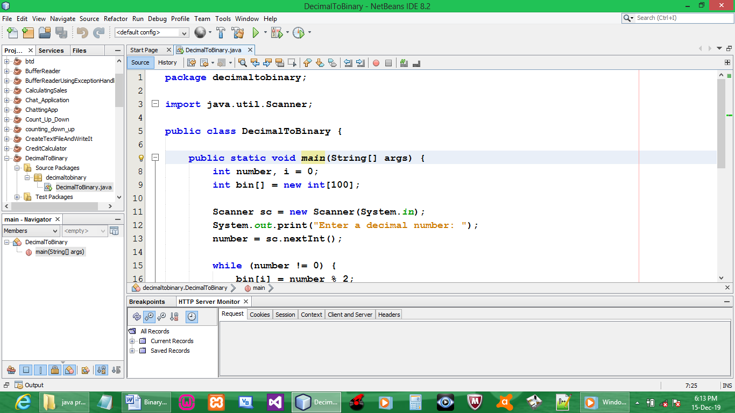

CODE:

package decimaltobinary;

import java.util.Scanner;

public class DecimalToBinary {

public static void main(String[] args) {
int number, i = 0;
int bin[] = new int[100];

Scanner sc = new Scanner(System.in);
System.out.print("Enter a decimal number: ");
number = sc.nextInt();

while (number != 0) {
bin[i] = number % 2;
number = number / 2;
i++;
}

System.out.print("The Binary value is: ");
for (int j = i - 1; j >= 0; j--){
System.out.print("" + bin[j]);
}
System.out.print("\n");
}
}

OUTPUT:

